Springfield Community Resources
Information on local and state resources to help students and families in need of mental health assistance.

988 Suicide & Crisis Lifeline: dial 988 (24/7) call or text

Trevor LGBTQ Lifeline: 866-488-7386 (24/7)

BHN Springfield-based Mobile Crisis Intervention (24/7): 413-733-6661

MA Dept. of Mental Health Emergency Line: 800-437-5922 (24/7)

Samaritans: 877-870-4673 (24/7)

Crisis Text Line - Text 741-741 (24/7)
Mental Health Resources
- African Diaspora Mental Health Association
- 605 State Street Springfield, MA 01109
New Clients call: 413-266-2207, Email: admin.office@admha.org.
Culturally-specific mental health services to promote social, emotional, economic, and behavioral health, and to establish long-standing resources for children/adults/families of All People, with special emphasis on the African Diaspora.

- BHN Emergency Services
- 417 Liberty Street, Springfield, MA 01104
Mental Health Emergency: 1-800-437-5922 (24/7 Crisis Line), 413-733-6661 or walk to clinic entrance B
Get immediate help for yourself or another person in a crisis situation. When you call, they will help you decide what steps are needed to improve your situation. Provide services for children, youth and family including addiction, mental health, developmental services, emergency services, healthcare integration and care management.

- CHD Outpatient Behavioral Health Clinic
- Locations throughout the Pioneer Valley. New Clients call: 1-844-CHD-HELP (844-243-4357)
Specialize in working with young children, teens, couples and families on depression, anxiety, grief, drug and alcohol issues, couples therapy, divorce mediation, family therapy, LGBTQ concerns, and refugee issues. English, Spanish, Arabic, Somali, German, Burmese, and Vietnamese spoken.

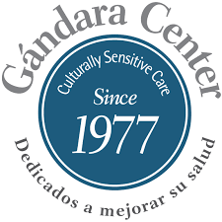
- Gandara Center
- 2155 Main Street, Springfield, MA 01104, (413) 736-0395 ext. 702
Open 8:00 a.m. – 6:00 p.m., Walk-ins welcome.
Outpatient Clinics offer a broad array of bilingual and bicultural clinical and addiction services for adults, families, children and adolescents include individual group psychotherapy, diagnostic assessments and treatment.

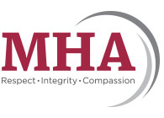
- Mental Health Association
- 995 Worthington Street. Springfield, MA 01109, 413-734-5376 (Office line), 413-785-5288 (TTY line)
Provides residential and support services for people impacted by mental illness, developmental disabilities, substance abuse, and homelessness with 21 residential sites, extensive outreach and supported living programs
- Mental Health Resources - NAMI
- Extensive list of links and resources, helplines, service providers, agencies, research and more. Also has a link to additional information on specific disorders.
- National Alliance on Mental Illness Support Groups - Western Massachusetts
- 324A Springfield Street
Agawam, MA 01001
NAMI Helpline: 1-800-950-NAMI (6264) M-F 10 am-8 pm
Crisis Text Line - Text NAMI to 741-741 (24/7)
Information: Call (413) 786-9139 or email information@namiwm.org
Open M-F 8:30 am - 3:00 pm
National Alliance on Mental Illness (NAMI) offers free support, education, referrals, and advocacy to people of all ages with mental health issues. Visit their support page: www.namiwm.org/support.html
- **NAMI COVID-19 Resource and Information Guide**
- This excellent resource answer frequently asked questions regarding the intersection between Coronavirus (COVID-19) and people affected by mental illness, their caregivers and loved ones. Features FAQs on a variety of topics from managing anxiety and social isolation to accessing health care and medications.
- River Valley Counseling Center
- For more information or to schedule an intake call 413-540-1234
Adult, adolescent and child outpatient therapy as well as AIDS/HIV support. Individual, family and group counseling with weekend and evening hours available. Bilingual. Sliding fee scale. All patients are served regardless of ability to pay. Call for an appointment.
- Clinical & Support Options
- 1 Federal St Building 102, Springfield MA 01109
(413) 737-9544
Services available for those in need of outpatient, psychiatry and crises services, and more. Located in the Technology Park walking distance from the STCC campus for anyone in need of support

Help Lines
- Call 2 Talk
- 1-508-532-2255 or Text C2T to 741-471
24/7, confidential, compassionate listening to assist people – including those who may be despondent or considering suicide – during stressful times.
- 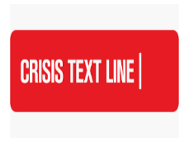
- Crisis Text Line
- Text HOME to 741-741
Serves anyone, in any type of crisis, providing access to free, 24/7 support and information from anywhere in the U.S.
- Samaritans
- Crisis counseling, suicide prevention and grief support for suicide loss.
- 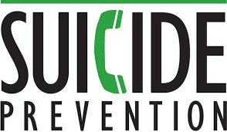
- Suicide Prevention Lifeline
- 1-800-273-TALK (8255)
Provides 24/7, free and confidential support for people in distress, and prevention and crisis resources for you or your loved ones

Behavioral Health Helpline
Massachusetts recently launched the new Behavioral Health Help Line. Free, confidential, 24/7, no health insurance necessary. Call, text or chat with a real person. (800)733-2445 or masshelpline.com. In person appointments are also available, throughout the state.
This hotline also includes Substance Use Services. Are you having a hard time and need help? Call even if you’re not sure what kind of help you need. It’s free, confidential, and no health insurance is required.

