PUTNAM ACADEMY – School Entrances
Below – please find a description of Putnam entrances and which entrance students should use.
Please note – these entrances are ONLY to be used in the morning before school.
Students arriving tardy need to enter through Door 6

FRONT (MAIN) DOOR:
This entrance is currently ONLY for Teachers, staff, Administrators and Grade 13 students. 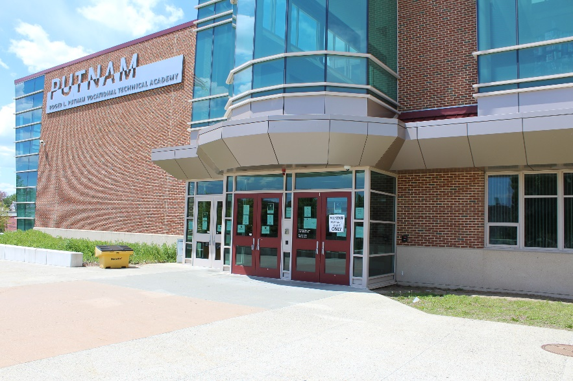

DOOR 6 – STUDENT DROP-OFF on Alton St. (near Cafeteria):
This entrance is for students with homeroom classes in A wing and the following shops:
Cosmetology / Culinary / Health Assisting / Early Childcare / Marketing / Horticulture
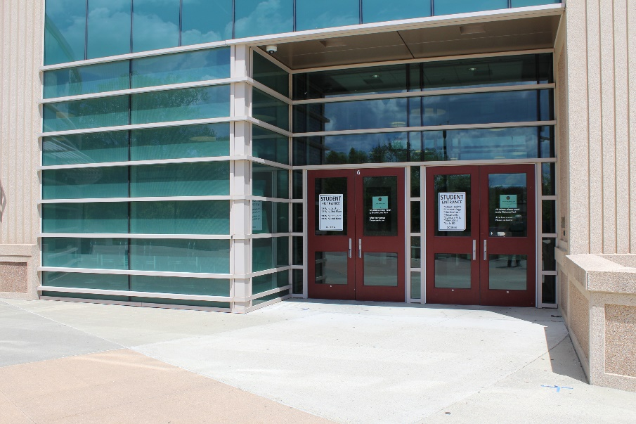

DOOR 9 – STUDENT DROP-OFF on Alton St. (at the other side of the Cafeteria):
This entrance is for students with homeroom classes in C/D wing and the following shops:
Auto Collision / Auto Technology
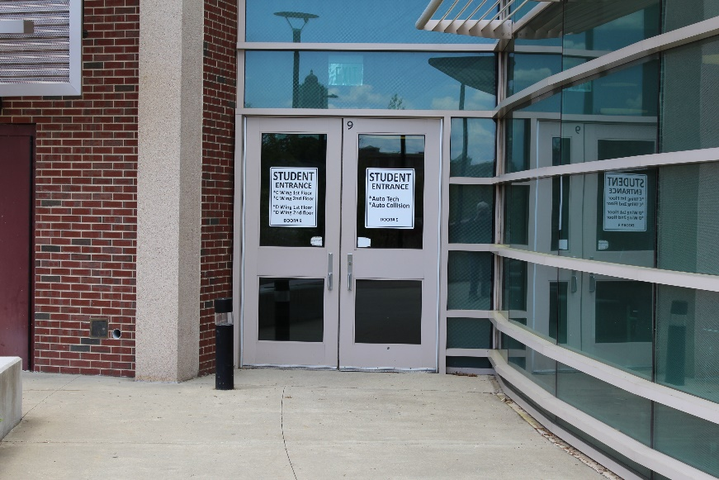

DOOR 30 – on Blunt Park Rd. (next to the Gym)
This entrance is for students with homeroom classes in E / F / G wing and the following shops:
Business Tech / Criminal Justice / Design & Visual / Graphics / I.T. / Radio & TV
Adv. Manufacturing / Robotics / Sheet Metal
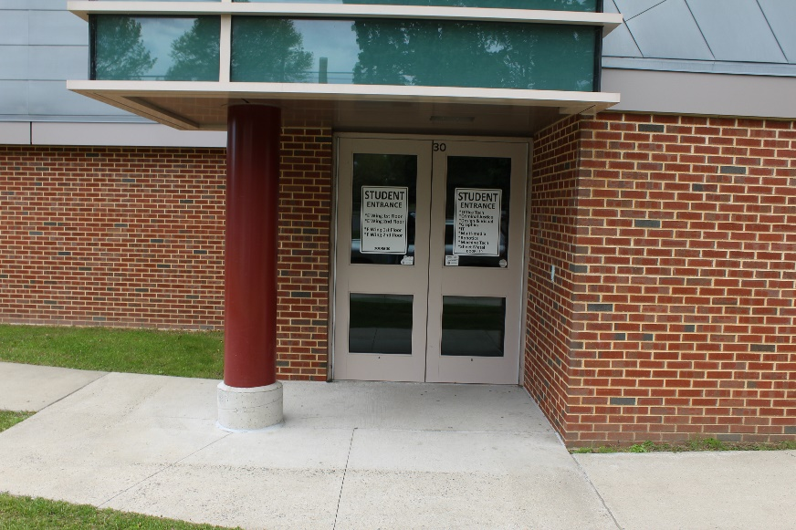

DOORS 26 & 28 – on Blunt Park Rd. (entrance near Roosevelt Ave.)
These entrances are for students with homeroom classes in F / G wing and the following shops:
Carpentry / Construction / Electric / HVAC

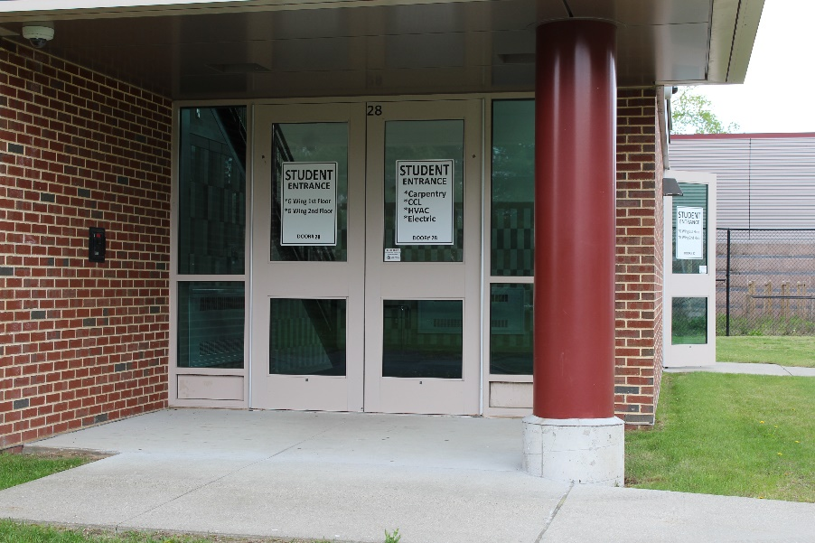

In the Main Hallway of the front entrance is Putnam Hall (below) which is A Wing . To the right is the E / F/ G Wing. To the left is C/D Wing
